[The Transformers Lore] Site Plan

[Isaac Heredia]

WDD 130

Overview

Purpose
[To explore the complete history of the Autobots and Decepticons of the Transformers universe]

Audience
[Fans and newcomers alike eager to learn about the Transformers]

Branding

Website Logo
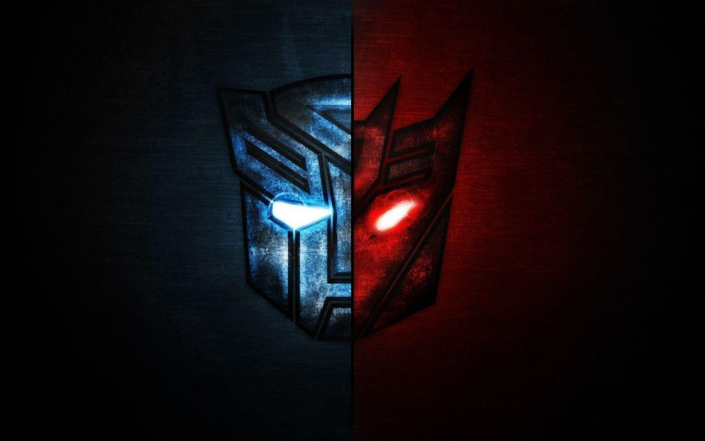

Style Guide

Color Palette
Primary | Secondary | Accent 1 | Accent 2
#D92121 | #8712B6 | #A8A9AD | #F2D638

Typography

Heading Font: [SF TransRobotics]

Paragraph Font: [Eurostile]

Navigation
Home Autobots Decepticons

Content

For the title page, it will be a brief overview of the origin story of the Transformers and how the Autobots and Decepticons came to be. Images will be shown of the Thirteen Primes, Orion Pax and Megatronus, and the beginning of the Cybertronian war.
The child page for the Autobots will hold a brief overview of the Autobots’ mission in each of the main TV shows. These include, but are not limited to, Generation 1, Beast Wars, Armada, Energon, Cybertron, Prime, Animated, War for Cybertron, etc. One image for each of these shows will be shown to demonstrate the type of animation used for the respective show. There will also be a list of all (or main) Autobots in the show.

The child page for the Decepticons will follow suit and provide a brief overview and mention key players for the Decepticons in each show, with an image to match each one.

Wireframes

Home
